Colorado Day at the Capitol
Monday, August 1, 2016

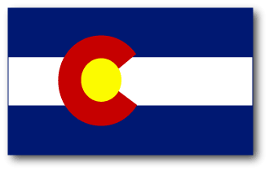
140TH Statehood Anniversary Celebration - Colorado “Then and Now”

History and Heritage Displays, North Foyer 9-3
Outdoor Performances and Exhibits, West Steps 10-11
Grand Celebration Ceremony, West Steps 11-12

- Remarks by Governor Hickenlooper, Mayor Hancock, Colorado State Poet Laureate Joseph Hutchison, History Colorado Executive Director and State Historic Preservation Officer Steve Turner, and other state dignitaries
- Dance and music performances by the Colorado National Guard’s 101st Army Band, the Colorado Dancers and Friends and the Colorado State Square Dance Association
- Have your photo taken with state summer heritage sport animal, Big Chief, the pack burro
- A celebration ceremony on the West Steps at 11 am, with a color guard, canon salute, ringing of the Liberty Bell, and birthday cake!
- Guess the number of Colorado-grown pinto beans for your chance to win the Mt. Elbert Gift Basket, featuring fine local Colorado products and tickets to local attractions

Exhibitors Include –

Byers-Evans House Museum History Colorado
Civic Center Conservancy Rocky Mountain Nat’l Park Environmental Education
Colorado Department of Agriculture, Colorado Proud Rocky Mountain Arsenal National Wildlife Refuge Colorado Department of State South Park National Heritage Area and Curtis Imrie
Colorado State Patrol Tesoro Foundation
Colorado School of Mines Geology Museum University of Denver Amache Research Project
Forney Museum of Transportation

Thank you to the following for their support – Adobe Milling Company, Clyfford Still Museum, Colorado General Assembly, Colorado Department of Military and Veterans Affair, Colorado Life Magazine, Colorado National Guard, Colorado State Capitol Summer Guides and Volunteers, Colorado State Patrol, Denver Art Museum, Denver Botanic Gardens, Enstrom Candies, History Colorado, King Soopers, Legislative Council Staff, Molly Brown House Museum, the Office of Governor John Hickenlooper, Rocky Mountain Soda Company, Tattered Cover Book Store

