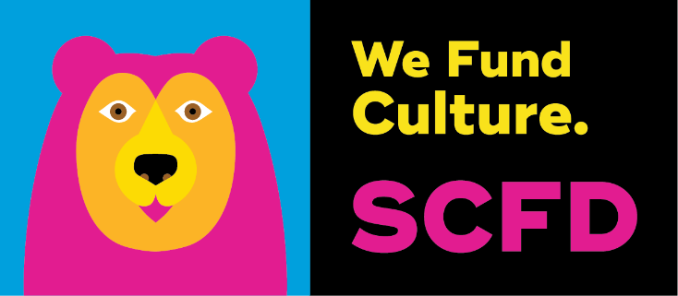
Written Testimony
Support
SB22-011 America 250 / Colorado 150 Commission
Sen. Rachel Zenzinger, Sen. Don Coram – Rep. Mark Caitlin, Rep. Daneya Esgar

The Scientific and Cultural Facilities District (SCFD) is a unique organization focused on serving constituents throughout the Denver-metro region and the State of Colorado as a whole. Facilities, events, and enrichment activities funded by the SCFD across our region make Colorado one of the most desirable places to live in the United States.
It is not very often that our organization gets the opportunity to advocate for a project outside of our immediate boundaries in the Denver-metro area.
We support SB22-11, Concerning the anniversary of our Nation and our State.
SB22-11 establishes the America 250 – Colorado 150 Commission: The commission is created by the Colorado State Legislature and directed to develop and promote plans for activities between July 1, 2025, and December 31, 2026, including historical activities, publication of historical documents, public ceremonies, educational activities for Colorado youth, and other commemorative events, to be supported by comprehensive marketing and tourism campaigns. The commission is also authorized to represent the state in official dealings with the United States semiquincentennial commission and the America250 foundation.
SCFD is proud to support SB22-11

Organizations In Support:


